Overall NYC Crime YR2017 are 458,035 complaints made to NYPD.

Top (# 1) five years crime decrease at end of 2017 are ‘Dangerous Drugs’.

Top (# 1) five years crime increase at end of 2017 is ‘HARRASSMENT 2’.

‘SEX CRIMES’ have increased over five years by 318 complaints.

Brooklyn has highest crime rate. However, it also has highest percentage increase in both price and rents in real estate market of New York City.

Manhattan still has the most expensive real estate with six figure crime rate per year.

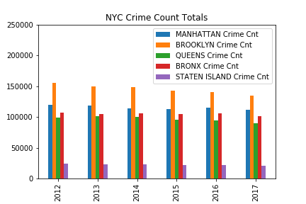

|  |  |  |  |  |
| --- | --- | --- | --- | --- |
| **Manhattan Crime %** | **Brooklyn Crime %** | **Queens Crime %** | **Bronx Crime %** | **Staten Island Crime %** |
| **-7%**  5YR | **-13%** | **-10%** | **-5%** | **-12%** |
| **111646**  (YR 2017) | **134713** | **89515** | **101305** | **20856** |

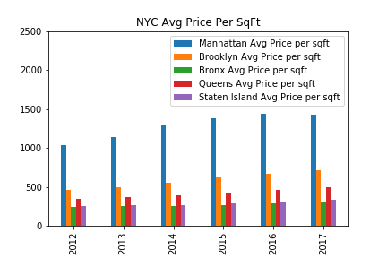

|  |  |  |  |  |
| --- | --- | --- | --- | --- |
| Manhattan | Brooklyn | Queens | Bronx | Staten Island |
| **38%**  5YR | **56%** | **41%** | **26%** | **30%** |
| **$1432**  Max Avg Per SqFt | **708** | **490** | **312** | **336** |

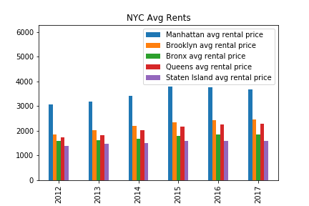

|  |  |  |  |  |
| --- | --- | --- | --- | --- |
| Manhattan | Brooklyn | Queens | Bronx | Staten Island |
| **19%**  5YR | **32%** | **32%** | **16%** | **15%** |
| **$3786**  Max Avg Monthly Rent | **2458** | **2275** | **1846** | **1601** |

Overall NYC Crime Decrease and Increase from year 2012 to end of 2017:

DANGEROUS DRUGS -12874.0

BURGLARY -7415.0

OFF. AGNST PUB ORD SENSBLTY & -6318.0

ROBBERY -6255.0

DANGEROUS WEAPONS -3428.0

ASSAULT 3 & RELATED OFFENSES -3220.0

OFFENSES AGAINST PUBLIC ADMINI -2781.0

GRAND LARCENY OF MOTOR VEHICLE -2474.0

THEFT-FRAUD -2316.0

GRAND LARCENY -2278.0

CRIMINAL TRESPASS -2196.0

POSSESSION OF STOLEN PROPERTY -1425.0

PETIT LARCENY -1144.0

INTOXICATED & IMPAIRED DRIVING -1080.0

FRAUDS -963.0

ARSON -596.0

OFFENSES INVOLVING FRAUD -525.0

THEFT OF SERVICES -351.0

ADMINISTRATIVE CODE -280.0

RAPE -234.0

MURDER & NON-NEGL. MANSLAUGHTER -146.0

OTHER STATE LAWS (NON PENAL LA -130.0

OFFENSES RELATED TO CHILDREN -121.0

FRAUDULENT ACCOSTING -111.0

KIDNAPPING & RELATED OFFENSES -72.0

DISORDERLY CONDUCT -69.0

OFFENSES AGAINST PUBLIC SAFETY -58.0

BURGLAR'S TOOLS -35.0

PROSTITUTION & RELATED OFFENSES -26.0

PETIT LARCENY OF MOTOR VEHICLE -12.0

HOMICIDE-NEGLIGENT-VEHICLE -10.0

JOSTLING -9.0

OTHER STATE LAWS -8.0

CHILD ABANDONMENT/NON SUPPORT -7.0

INTOXICATED/IMPAIRED DRIVING -4.0

UNLAWFUL POSS. WEAP. ON SCHOOL -3.0

DISRUPTION OF A RELIGIOUS SERV -3.0

ANTICIPATORY OFFENSES -3.0

OTHER STATE LAWS (NON PENAL LAW) -2.0

LOITERING -1.0

ESCAPE 3 -1.0

NEW YORK CITY HEALTH CODE 5.0

LOITERING/GAMBLING (CARDS, DIC 8.0

ENDAN WELFARE INCOMP 9.0

HOMICIDE-NEGLIGENT,UNCLASSIFIE 11.0

GAMBLING 55.0

ALCOHOLIC BEVERAGE CONTROL LAW 56.0

OFFENSES AGAINST THE PERSON 87.0

UNAUTHORIZED USE OF A VEHICLE 141.0

NYS LAWS-UNCLASSIFIED FELONY 252.0

FELONY ASSAULT 314.0

SEX CRIMES 318.0

OTHER OFFENSES RELATED TO THEF 421.0

CRIMINAL MISCHIEF & RELATED OF 725.0

VEHICLE AND TRAFFIC LAWS 865.0

MISCELLANEOUS PENAL LAW 986.0

FORGERY 1362.0

HARRASSMENT 2 8400.0

Top 20 NYC Crimes for year 2017:

PETIT LARCENY 82018

HARRASSMENT 2 65421

ASSAULT 3 & RELATED OFFENSES 51277

CRIMINAL MISCHIEF & RELATED OF 48514

GRAND LARCENY 40683

DANGEROUS DRUGS 21807

OFF. AGNST PUB ORD SENSBLTY & 21095

FELONY ASSAULT 19875

ROBBERY 13918

MISCELLANEOUS PENAL LAW 13072

BURGLARY 11896

DANGEROUS WEAPONS 8665

OFFENSES AGAINST PUBLIC ADMINI 7937

VEHICLE AND TRAFFIC LAWS 6435

SEX CRIMES 5884

INTOXICATED & IMPAIRED DRIVING 5647

GRAND LARCENY OF MOTOR VEHICLE 5594

FORGERY 5180

THEFT-FRAUD 3807

CRIMINAL TRESPASS 3599